**PRACTICAL :- 1**

**Write the following programs for Blockchain in Python**

**Practical 1A:-**

**Aim:-** A simple client class that generates the private and public keys by using the builtin Python RSA algorithm and test it.

**Code:-**

# Import necessary modules from the cryptography library

from cryptography.hazmat.primitives.asymmetric import rsa

from cryptography.hazmat.primitives import serialization

from cryptography.hazmat.backends import default_backend

from cryptography.hazmat.primitives import hashes

from cryptography.hazmat.primitives.asymmetric import padding

# Define a SimpleRSA_Client class

class SimpleRSA_Client:

def __init__(self):

# Initialize private_key and public_key attributes

self.private_key = None

self.public_key = None

def generate_keys(self):

# Generate private key

self.private_key = rsa.generate_private_key(

public_exponent=65537, # Public exponent value for the RSA key

key_size=2048, # Key size (in bits) for the RSA key

backend=default_backend() # Use the default backend

)

# Generate corresponding public key from the private key

self.public_key = self.private_key.public_key()

def encrypt_message(self, message):

if not self.public_key:

raise ValueError("Public key is missing. Generate keys first.")

# Encrypt the provided message using the public key

ciphertext = self.public_key.encrypt(

message.encode(), # Convert the message to bytes

padding.OAEP( # Use OAEP padding scheme

mgf=padding.MGF1(algorithm=hashes.SHA256()), # Mask Generation Function

algorithm=hashes.SHA256(), # Hashing algorithm

label=None # No additional label

)

)

return ciphertext

def decrypt_message(self, ciphertext):

if not self.private_key:

raise ValueError("Private key is missing. Generate keys first.")

# Decrypt the provided ciphertext using the private key

plaintext = self.private_key.decrypt(

ciphertext, # The ciphertext to decrypt

padding.OAEP( # Use OAEP padding scheme (should match the one used for encryption)

mgf=padding.MGF1(algorithm=hashes.SHA256()), # Mask Generation Function

algorithm=hashes.SHA256(), # Hashing algorithm

label=None # No additional label

)

)

return plaintext.decode() # Decode the decrypted bytes to a string

# Testing the Simple RSA Client

if __name__ == "__main__":

# Create an instance of SimpleRSA_Client

client = SimpleRSA_Client()

# Generate RSA keys

client.generate_keys()

# Message to be encrypted

message = "Hello, Simple RSA by Muskan!"

# Encrypt the message

ciphertext = client.encrypt_message(message)

print("Encrypted Message:")

print(ciphertext)

print()

# Decrypt the ciphertext

decrypted_message = client.decrypt_message(ciphertext)

print("Decrypted Message:")

print(decrypted_message).

**Output:-**

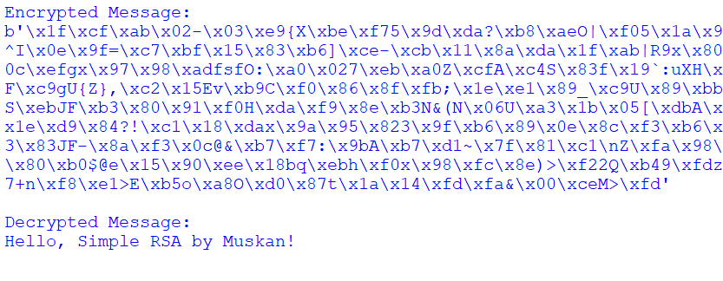

**Practical 1B:-**

**Aim:-** A transaction class to send and receive money and test it

**Code:-**

class Transaction:

def __init__(self, initial_balance=0):

self.balance = initial_balance

def send_money(self, amount):

if amount <= 0:

raise ValueError("Amount must be greater than zero.")

if self.balance < amount:

raise ValueError("Insufficient funds.")

self.balance -= amount

return amount

def receive_money(self, amount):

if amount <= 0:

raise ValueError("Amount must be greater than zero.")

self.balance += amount

return amount

# Testing the Transaction class

if __name__ == "__main__":

# Create a new transaction object with initial balance of 100

transaction = Transaction(initial_balance=100)

print("Initial Balance:", transaction.balance)

# Send money

sent_amount = transaction.send_money(50)

print("Sent Amount:", sent_amount)

print("Current Balance after sending:", transaction.balance)

# Receive money

received_amount = transaction.receive_money(30)

print("Received Amount:", received_amount)

print("Current Balance after receiving:", transaction.balance)

# Trying to send more than balance

try:

transaction.send_money(80)

except ValueError as e:

print("Error:", e)

# Trying to send negative amount

try:

transaction.send_money(-10)

except ValueError as e:

print("Error:", e)

# Print initial balances of both users

**Output:-**

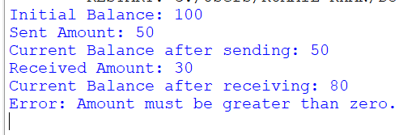

**Practical 1C:-**

**Aim:-** Create multiple transactions and display them.

**Code:-**

class Transaction:

def __init__(self, initial_balance=0):

self.balance = initial_balance

def send_money(self, amount):

if amount <= 0:

raise ValueError("Amount must be greater than zero.")

if self.balance < amount:

raise ValueError("Insufficient funds.")

self.balance -= amount

return amount

def receive_money(self, amount):

if amount <= 0:

raise ValueError("Amount must be greater than zero.")

self.balance += amount

return amount

# Create multiple transactions

transactions = [

Transaction(100), # Transaction 1 with initial balance of 100

Transaction(50), # Transaction 2 with initial balance of 50

Transaction(200) # Transaction 3 with initial balance of 200

]

# Perform transactions

transactions[0].send_money(30) # Transaction 1 sends 30

transactions[1].receive_money(20) # Transaction 2 receives 20

transactions[2].send_money(50) # Transaction 3 sends 50

transactions[0].receive_money(10) # Transaction 1 receives 10

# Display transactions and balances

for i, transaction in enumerate(transactions, 1):

print(f"Transaction {i} Balance:", transaction.balance)

**Output:-**

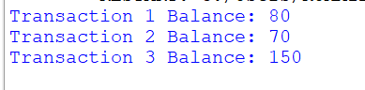

**Practical 1D:-**

**Aim:-** Create a blockchain, a genesis block and execute it.

**Code:-**

import hashlib

import time

class Block:

def __init__(self, index, timestamp, data, previous_hash):

self.index = index

self.timestamp = timestamp

self.data = data

self.previous_hash = previous_hash

self.hash = self.calculate_hash()

def calculate_hash(self):

"""

Calculate the hash of the block using its properties.

"""

block_info = str(self.index) + str(self.timestamp) + str(self.data) + str(self.previous_hash)

return hashlib.sha256(block_info.encode()).hexdigest()

class Blockchain:

def __init__(self):

self.chain = [self.create_genesis_block()]

def create_genesis_block(self):

"""

Create the first block (genesis block) of the blockchain.

"""

return Block(0, time.time(), "Genesis Block", "0")

def add_block(self, data):

"""

Add a new block to the blockchain.

"""

previous_block = self.chain[-1]

new_block = Block(len(self.chain), time.time(), data, previous_block.hash)

self.chain.append(new_block)

def print_chain(self):

"""

Print the contents of the blockchain.

"""

for block in self.chain:

print(f"Index: {block.index}")

print(f"Timestamp: {block.timestamp}")

print(f"Data: {block.data}")

print(f"Previous Hash: {block.previous_hash}")

print(f"Hash: {block.hash}")

print()

# Create a blockchain

blockchain = Blockchain()

# Print the initial state (genesis block)

print("Initial Blockchain State (Genesis Block):")

blockchain.print_chain()

# Add new blocks to the blockchain

blockchain.add_block("Transaction 1")

blockchain.add_block("Transaction 2")

# Print the updated blockchain

print("Updated Blockchain State:")

blockchain.print_chain()

**Output:-**

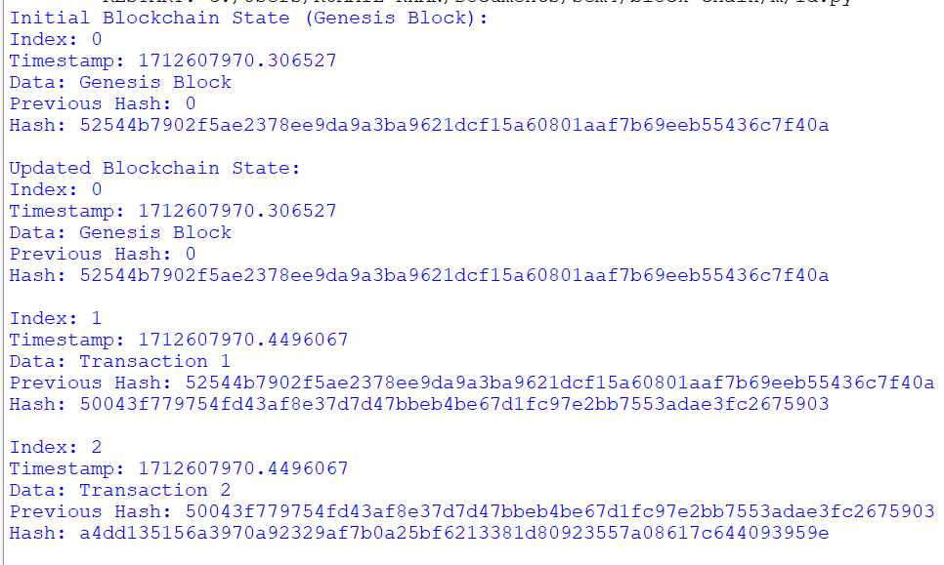

**Practical 1E:-**

**Aim:-** Create a mining function and test it

**Code:-**

import hashlib # Library for hashing

import time # Library for timestamp

class Block:

def __init__(self, index, timestamp, data, previous_hash):

"""

Constructor for Block class.

Args:

index: Index of the block in the blockchain.

timestamp: Timestamp of when the block was created.

data: Data or transaction details stored in the block.

previous_hash: Hash of the previous block in the chain.

"""

self.index = index

self.timestamp = timestamp

self.data = data

self.previous_hash = previous_hash

self.hash = self.calculate_hash() # Calculate hash of the block

def calculate_hash(self):

"""

Calculate the hash of the block using its properties.

"""

# Concatenate block properties into a single string

block_info = str(self.index) + str(self.timestamp) + str(self.data) + str(self.previous_hash)

# Hash the concatenated string using SHA-256 and return the hexadecimal digest

return hashlib.sha256(block_info.encode()).hexdigest()

class Blockchain:

def __init__(self):

"""

Constructor for Blockchain class.

"""

self.chain = [self.create_genesis_block()] # Initialize blockchain with genesis block

self.difficulty = 2 # Set difficulty level for mining

def create_genesis_block(self):

"""

Create the first block (genesis block) of the blockchain.

"""

# The genesis block has index 0, a timestamp, static data "Genesis Block",

# and a previous hash of "0" (since it's the first block)

return Block(0, time.time(), "Genesis Block", "0")

def get_last_block(self):

"""

Get the last block in the blockchain.

"""

# The last block in the chain is simply the last element of the chain list

return self.chain[-1]

def mine_block(self, data):

"""

Mine a new block with the provided data.

Args:

data: Data or transaction details for the new block.

"""

# Get the last block in the chain

last_block = self.get_last_block()

# Create a new block with incremented index, current timestamp, provided data,

# and the hash of the previous block as the previous hash

new_block = Block(last_block.index + 1, time.time(), data, last_block.hash)

# Proof of Work: Find a hash that starts with the required number of zeros (difficulty)

while not new_block.hash.startswith('0' * self.difficulty):

new_block.timestamp = time.time() # Update timestamp for each attempt

new_block.hash = new_block.calculate_hash() # Recalculate the hash

# Once a valid hash is found (meets difficulty requirement), add the block to the chain

self.chain.append(new_block)

return new_block

def print_chain(self):

"""

Print the contents of the blockchain.

"""

for block in self.chain:

# Print details of each block: index, timestamp, data, previous hash, and hash

print(f"Index: {block.index}")

print(f"Timestamp: {block.timestamp}")

print(f"Data: {block.data}")

print(f"Previous Hash: {block.previous_hash}")

print(f"Hash: {block.hash}")

print()

# Create a blockchain instance

blockchain = Blockchain()

# Print the initial state of the blockchain (genesis block)

print("Initial Blockchain State (Genesis Block):")

blockchain.print_chain()

# Mine new blocks with some example data

blockchain.mine_block("Transaction 1")

blockchain.mine_block("Transaction 2")

# Print the updated state of the blockchain after mining

print("Updated Blockchain State:")

blockchain.print_chain()

**Output:-**

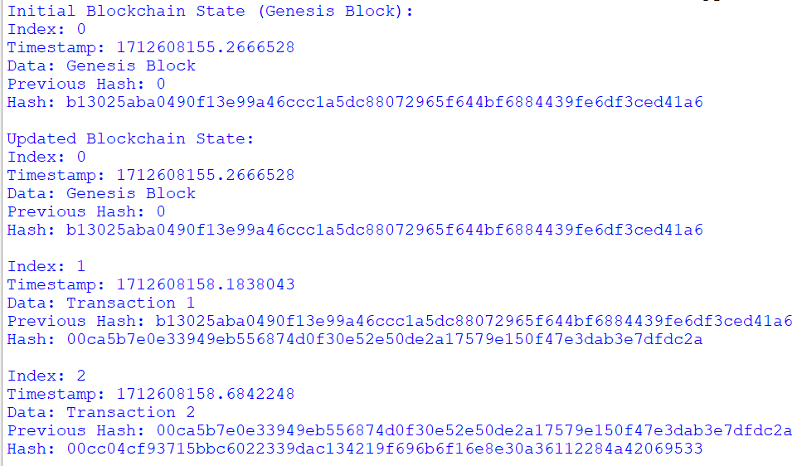

**Practical 1F:-**

**Aim:-** Add blocks to the miner and dump the blockchain.

**Code:-**

import hashlib

import time

class Block:

def __init__(self, index, timestamp, data, previous_hash):

"""

Constructor for Block class.

Args:

index: Index of the block in the blockchain.

timestamp: Timestamp of when the block was created.

data: Data or transaction details stored in the block.

previous_hash: Hash of the previous block in the chain.

"""

self.index = index

self.timestamp = timestamp

self.data = data

self.previous_hash = previous_hash

self.hash = self.calculate_hash() # Calculate hash of the block

def calculate_hash(self):

"""

Calculate the hash of the block using its properties.

"""

# Concatenate block properties into a single string

block_info = str(self.index) + str(self.timestamp) + str(self.data) + str(self.previous_hash)

# Hash the concatenated string using SHA-256 and return the hexadecimal digest

return hashlib.sha256(block_info.encode()).hexdigest()

class Blockchain:

def __init__(self):

"""

Constructor for Blockchain class.

"""

self.chain = [self.create_genesis_block()] # Initialize blockchain with genesis block

self.difficulty = 2 # Set difficulty level for mining

def create_genesis_block(self):

"""

Create the first block (genesis block) of the blockchain.

"""

# The genesis block has index 0, a timestamp, static data "Genesis Block",

# and a previous hash of "0" (since it's the first block)

return Block(0, time.time(), "Genesis Block", "0")

def get_last_block(self):

"""

Get the last block in the blockchain.

"""

# The last block in the chain is simply the last element of the chain list

return self.chain[-1]

def mine_block(self, data):

"""

Mine a new block with the provided data.

Args:

data: Data or transaction details for the new block.

"""

# Get the last block in the chain

last_block = self.get_last_block()

# Create a new block with incremented index, current timestamp, provided data,

# and the hash of the previous block as the previous hash

new_block = Block(last_block.index + 1, time.time(), data, last_block.hash)

# Proof of Work: Find a hash that starts with the required number of zeros (difficulty)

while not new_block.hash.startswith('0' * self.difficulty):

new_block.timestamp = time.time() # Update timestamp for each attempt

new_block.hash = new_block.calculate_hash() # Recalculate the hash

# Once a valid hash is found (meets difficulty requirement), add the block to the chain

self.chain.append(new_block)

return new_block

def dump_blockchain(self):

"""

Dump the entire blockchain by printing the contents of each block.

"""

print("Dumping Blockchain:")

for block in self.chain:

# Print details of each block: index, timestamp, data, previous hash, and hash

print(f"Index: {block.index}")

print(f"Timestamp: {block.timestamp}")

print(f"Data: {block.data}")

print(f"Previous Hash: {block.previous_hash}")

print(f"Hash: {block.hash}")

print()

# Create a blockchain instance

blockchain = Blockchain()

# Print the initial state of the blockchain (genesis block)

print("Initial Blockchain State (Genesis Block):")

blockchain.dump_blockchain()

# Mine new blocks with some example data

blockchain.mine_block("Transaction 1")

blockchain.mine_block("Transaction 2")

blockchain.mine_block("Transaction 3")

# Print the updated state of the blockchain after mining

print("Updated Blockchain State:")

blockchain.dump_blockchain()

**Output:-**

